**GAP Analysis Document**

Of

**Examination module**

For Implementation of

**Campus Management Software**

at

**World Skill Center (WSC)**





**Sustainable Outreach And Universal**

**Leadership (SOUL) Limited**

**Contents**

A. Introduction 2

B. Overview of the Document 3

C. List of Screen 4

D. Examination 6

1. Examination Master 6

1.1 Grading Scale 6

2. Examination 6

2.1 Exam Declaration 6

2.2 Exam Paper Setting 7

3. Evaluation 8

3.1 Exam Evaluation Plan 8

3.2 Criteria Wise Evaluation 9

3.3 Continuous Evaluation 9

3.4 Final Exam Result 10

4. Tools 11

4.1 Criteria Wise Evaluation Tool 11

4.2 Continuous Evaluation Tool 11

4.3 Final Result Declaration 11

4.4 Cumulative Mark sheet Tool 12

4.5 Migration Certificate Tool 12

4.6 Conduct Certificate Tool 13

5. Transcripts 13

5.1 Leaving Certificate 13

5.2 Provisional Certificate 14

5.3 Conduct Certificate 14

5.4 Cumulative Marksheet 15

# **Introduction**

The World Skill Center (WSC) is a premier advanced skill training institute established by the Government of Odisha, Skill Development and Technical Education Department, through the Odisha Skill Development Authority (OSDA). The WSC will impart advanced skill training in eight trades from engineering and service sectors. WSC caters primarily to induct the best talent from ITIs and Polytechnics and train them to become globally employable in emerging areas such as "Industry 4.0". WSC is housed in a state-of-the-art, 18-storey, air-conditioned building with nearly half a million square feet of space in the heart of capital city of Bhubaneswar.

With the Implementation of campus management software for WSC the goal is to streamline the operations and functions of the campus by integrating various processes, such as admissions, course registration, academic progress tracking, and financial management, HRMS, Procurement and Inventory management, etc into a unified system. The implementation also aims at providing a user-friendly interface for all stakeholders, making it easier for them to access the necessary information and complete their tasks with ease. The modules to be covered during the implementation of the software includes:

|  |  |
| --- | --- |
| Students Management Modules | Infrastructure Management |
| Academic System | Finance and Accounting System |
| Procurement & Inventory Management | Training and Placement |
| Human Resources Management System | Application Integration |

# **Overview of the Document**

The Gap analysis document is a detailed report that provides an overview of the

gaps between the current state of the project and the desired state, and develop recommendations to close those gaps. Conducting a gap analysis can help us to improve our product and profitability by allowing us to pinpoint “gaps” present in our software. Once it’s complete, we will be able to better focus on our resources and energy on those identified areas in order to improve them.

This document covers all the gaps between the existing software and functional requirements provided by WSC SME’s for Hostel module.

# **List of Screen**

The table below is list of screens present for the Examination module. Yes in Change in Existing column means that there will be change for a existing screen in the Campus management software, while Is new screen means the screen is not present in the existing software and will be newly developed. This document contains list of changes in existing screens, while requirements for new screens are covered in the SRS document.

|  |  |  |  |
| --- | --- | --- | --- |
| **SL no** | **Name of the Screens** | **Changes in Existing** | **Is New Screen ?** |
|  | Exam Type | No | No |
|  | Assessment Criteria | No | No |
|  | Grading Scale | Yes | No |
|  | Student Exam Block Criteria | No | No |
|  | Exam Declaration | Yes | No |
|  | Exam Evaluation Plan | Yes | No |
|  | Exam Application | Yes | No |
|  | Exam Paper Setting | Yes | No |
|  | Criteria Wise Evaluation | Yes | No |
|  | Criteria Wise Evaluation Tool | Yes | No |
|  | Continuous Evaluation | Yes | No |
|  | Continuous Evaluation Tool | Yes | No |
|  | Final Exam Result | Yes | No |
|  | Final Result Declaration Tool | Yes | No |
|  | Module Wise Pass Percentage | No | Yes |
|  | Course Wise Pass Percentage | No | Yes |
|  | Back Paper Tracking | No | Yes |
|  | Cumulative Marksheet | Yes | No |
|  | Cumulative Marksheet Tool | Yes | No |
|  | Leaving Certificate | Yes | No |
|  | Leaving Certificate Tool | No | No |
|  | Provisional Certificate | Yes | No |
|  | Provisional Certificate Tool | No | No |
|  | Migration Certificate | No | No |
|  | Migration Certificate Tool | Yes | No |
|  | Conduct Certificate | Yes | No |
|  | Conduct Certificate Tool | Yes | No |

# **Examination**

## **Examination Master**

### **Grading Scale**

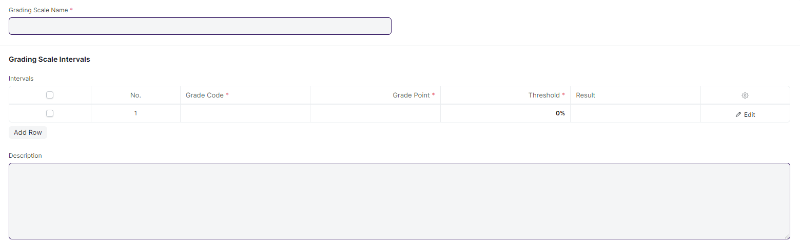

#### **Description of Changes:**

* WSC doesn’t need CGPA, they use module-wise grade

Note:

**Data changes**

The grading scale will be :

A> 80

B 70-79

C 60-69

D 50-59

F <50

## **Examination**

### **Exam Declaration**

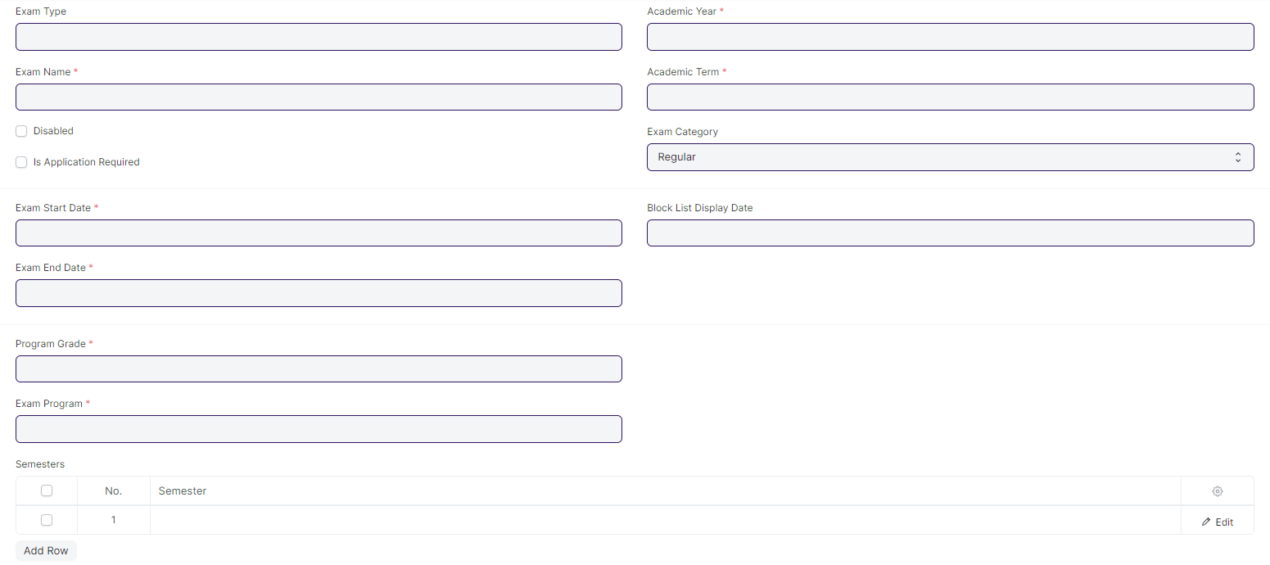

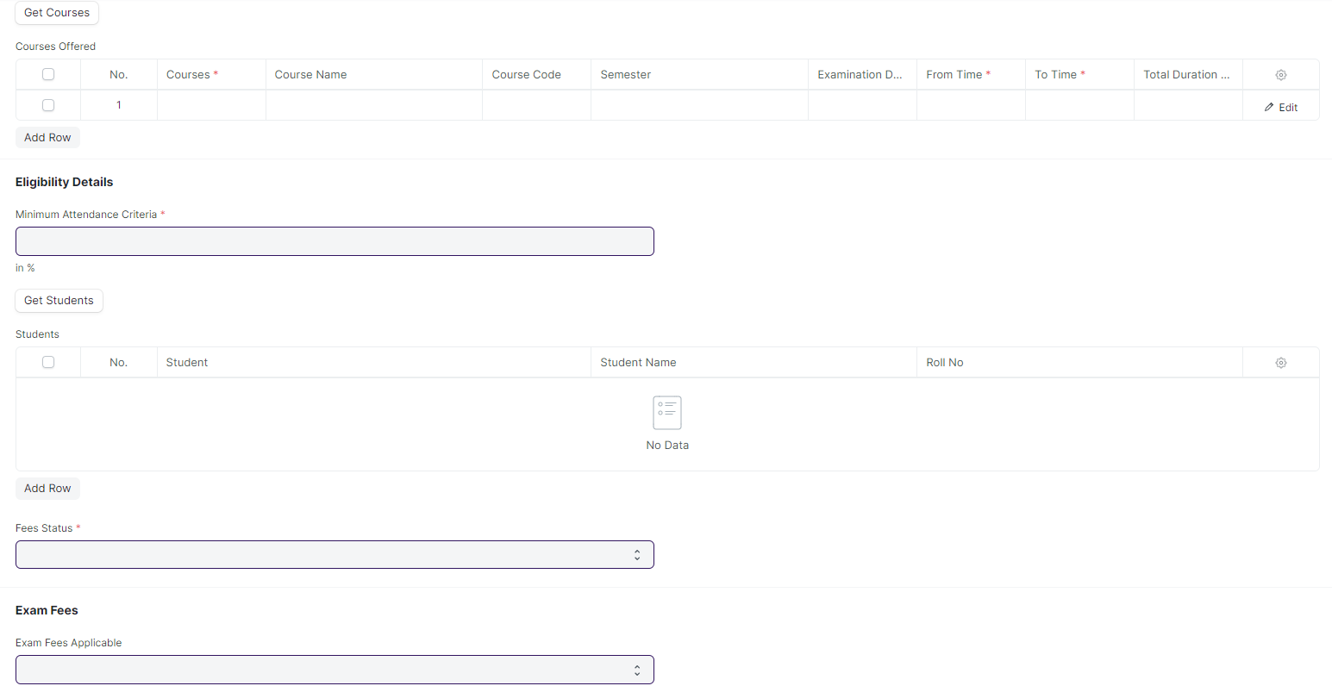

#### **Description of Changes:**

* One field must be added to the course offered table of the **Exam Declaration** screen to identify the conducting venue for their respective courses.
* A provision to assign an invigilator, a marker, and a checker should be included in the exam declaration screen for a specific course.
* Renaming of labels from Program grade, Exam program, Get courses, and Courses Offered to Course Grade, Exam Course, Get Modules, and Modules Offered respectively. Similarly, field label renaming in Courses Offered child table from Courses, Course Name, and Course code to Modules, Modules Name, and Modules Code respectively.
* If a student fails either semester 1, they will have to take a retest before the start of semester 2.
* Need to make a reminder for students and instructors regarding exams and send it before a certain time period. It should be applicable for both In-Module/End-Module. Also, reminder notifications could be sent to students /instructors prior to exam
* One of the user roles will be exam co-coordinator
* For attendance sheet, format must be the same across multiple modules but will have the name of respective modules, dates , student names and course name.
* Also must have a provision for downloading the template and student will sign in the attendance sheet.
* Once the semester starts, exam schedule is provided to the students within 15/30 days
* In-module academic calendar is issued 1 month prior to semester.
* The attendance Sheet will have Sl.No , name and sign (hard copy where students might sign) SOE - 4 courses, SOS - 2 courses. 1 academic year will have 2 semesters .Each semester is of 6 month duration.

### **Exam Paper Setting**

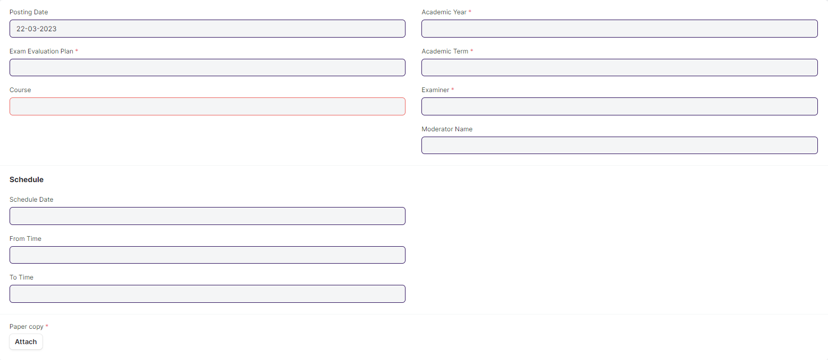

#### **Description of Changes:**

* After the paper setter and moderator list is published (via mail message will be sent to every paper setter and moderator regarding their respective courses), the paper setter will take three weeks to set the paper, and the moderator will take one week to check the paper sets.
* Once the paper setter created the paper sets,
* Then reminder sent to the director and Examination Head for review through mail
* Paper sets needs to be approved either by director or Examination Head
* Mail will be triggered to the paper setter and director when approved by Examination Head or mail will be triggered to the paper setter and Examination Head when approved by Director, then only it will be a viable exam question paper.

## **Evaluation**

### **Exam Evaluation Plan**

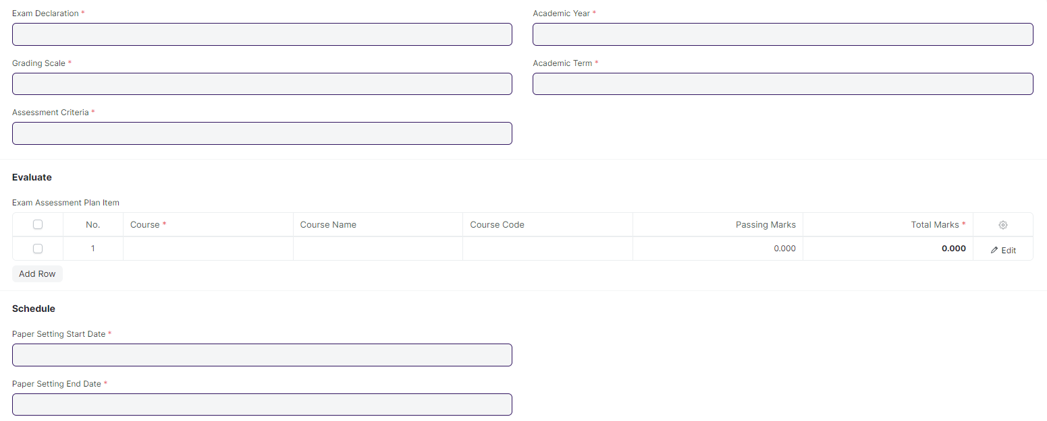

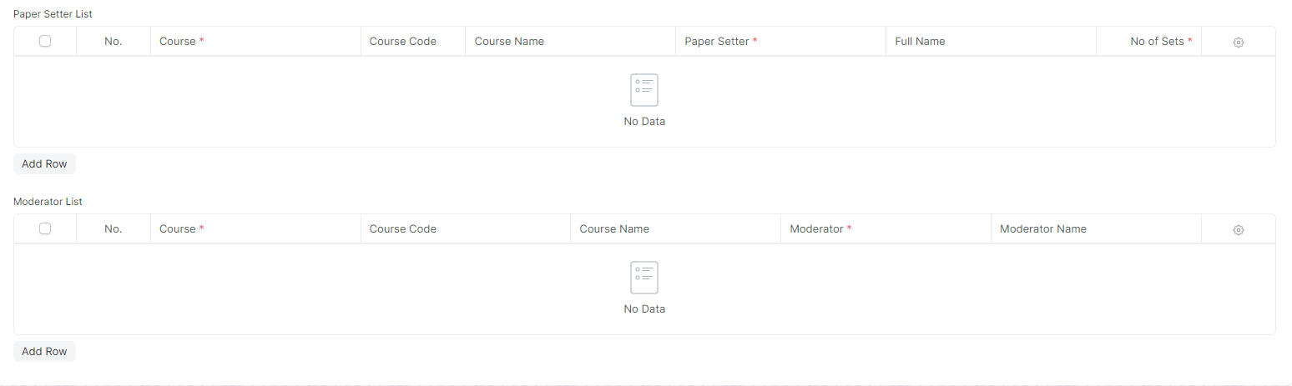

#### **Description of Changes:**

* Renaming of label from Programs to Course. Similarly in the associated child tables renaming of labels required for Course, Course Name, and Course Code to Module, Module Name, and Module Code.

### **Criteria Wise Evaluation**

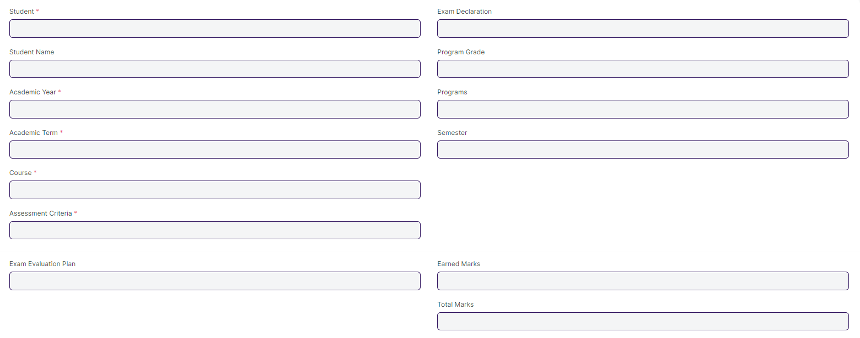

#### **Description of Changes:**

* Renaming of labels is required for Course, Course Name, Course Code, Program Grade, and Programs to Module, Module Name, Module Code, Course Grade, and Course respectively.

### **Continuous Evaluation**

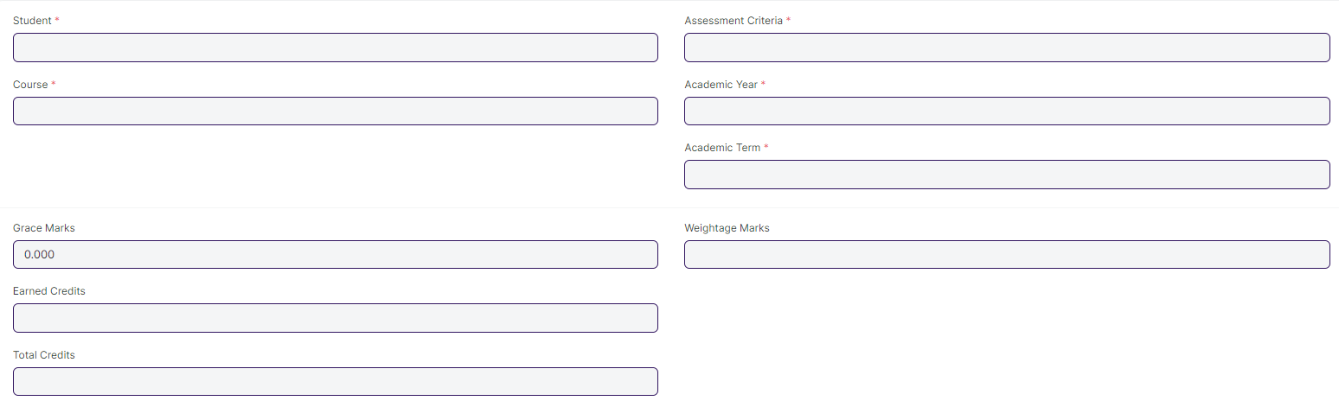

#### **Description of Changes:**

* Renaming of labels is required for Course, Course Name, and Course Code to Module, Module Name, and Module Code respectively.
* Note:

**Data Change**

The weight-age for In-module is 60% and End-module is 40%

### **Final Exam Result**

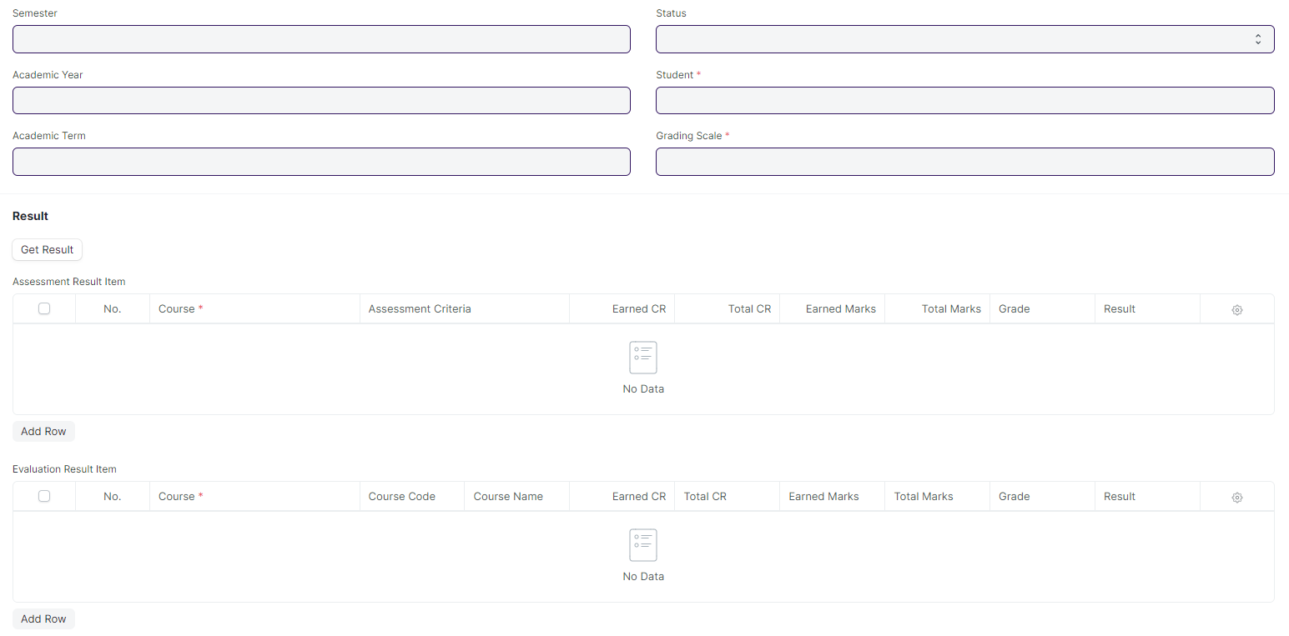

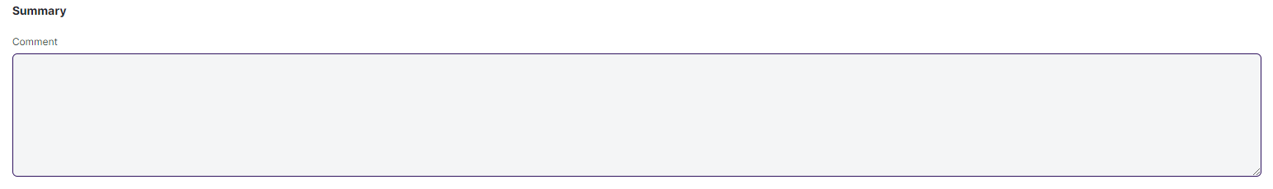

#### **Description of Changes:**

* Remove/Hide the CGPA, SGPA, and Credit features from the Final Exam Result and display the percentage and grade instead.
* Students must have access to view their results/reports
* A pictorial representation of student’s final results is required
* If a student is absent or failed during a semester exam, then student's data such as next program enrollment should not affect.
* Renaming of labels is required for Course, Course name, Course Code and Programs to Module, Module Name, Module Code, and Course respectively.

## **Tools**

### **Criteria Wise Evaluation Tool**

#### 

#### **Description of Changes:**

* Renaming of labels is required for Course, Course Name, Course Code, Program Grade, and Programs to Module, Module Name, Module Code, Course Grade, and Course respectively.

### **Continuous Evaluation Tool**

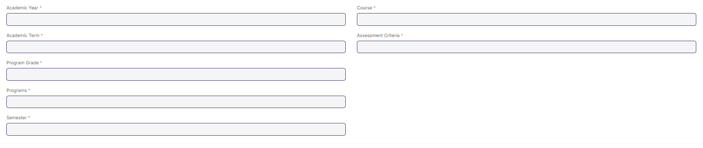

#### **Description of Changes:**

* Renaming of labels is required for Course, Course Name, Course Code, Program Grade, and Programs to Module, Module Name, Module Code, Course Grade, and Course respectively.

### **Final Result Declaration**

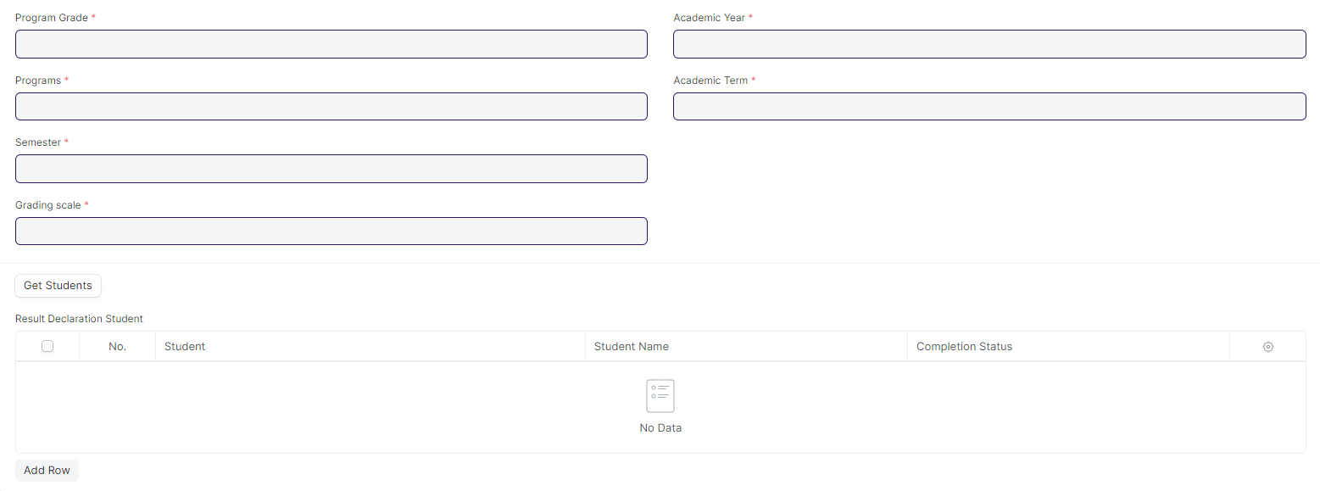

#### **Description of Changes:**

* No changes needed as discussed.

### **Cumulative Mark sheet Tool**

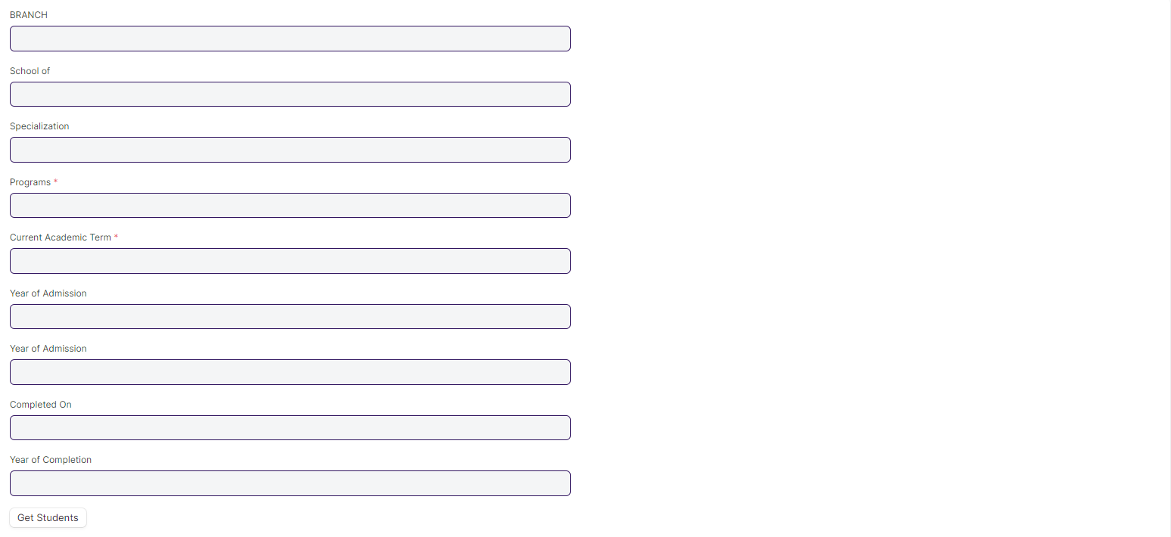

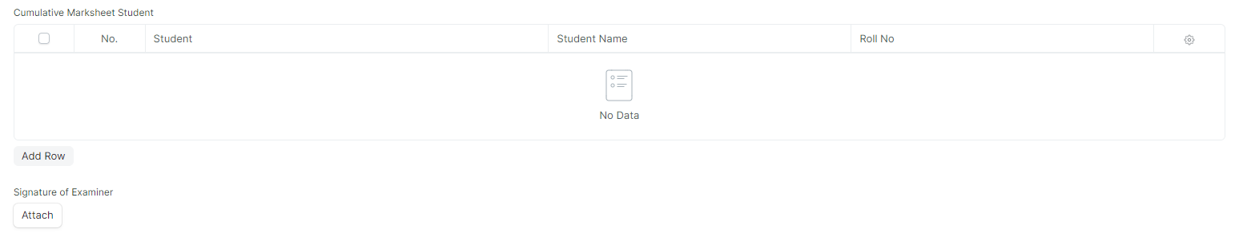

#### **Description of Changes:**

* Remove/Hide the CGPA, SGPA, and Credit features from the Cumulative Mark sheet and display the percentage and grade instead.

### **Migration Certificate Tool**

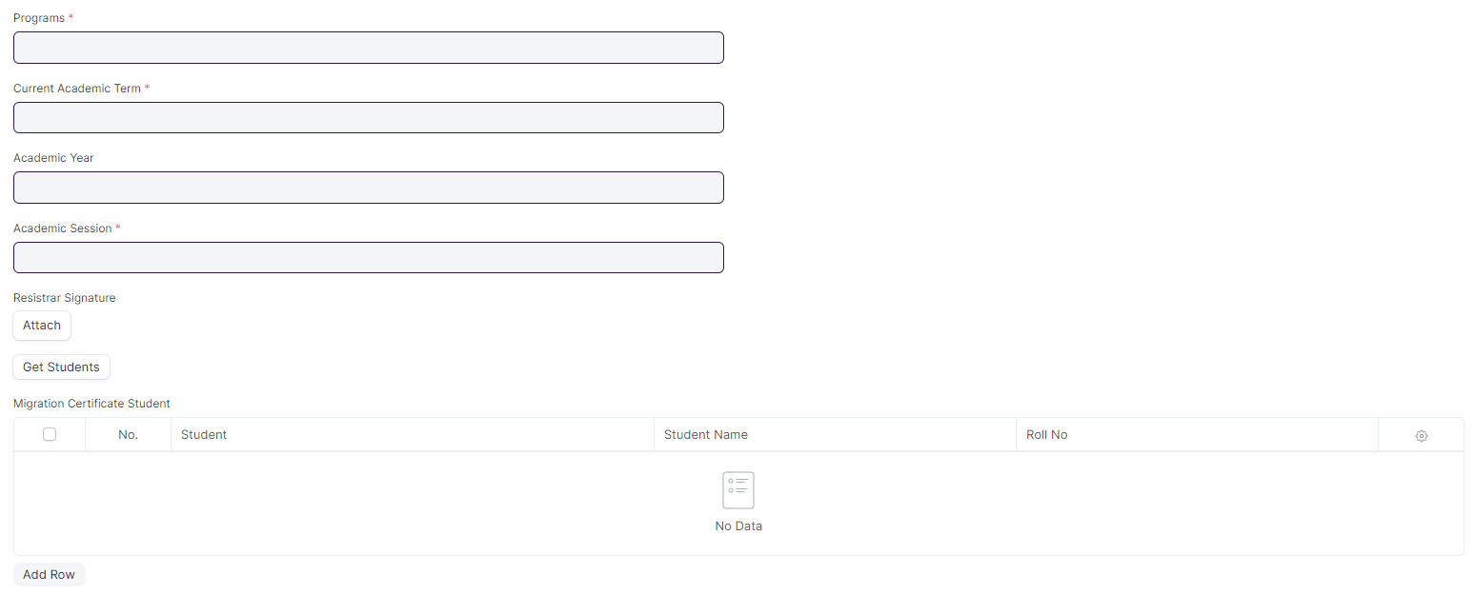

#### **Description of Changes:**

* Label Renaming is required for Program to Course.

### **Conduct Certificate Tool**

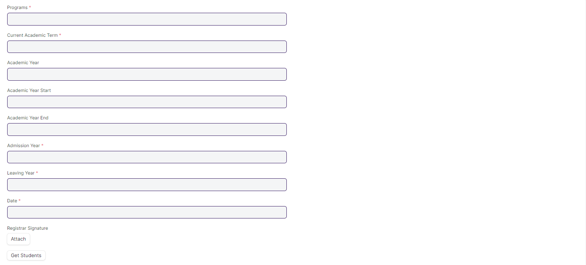

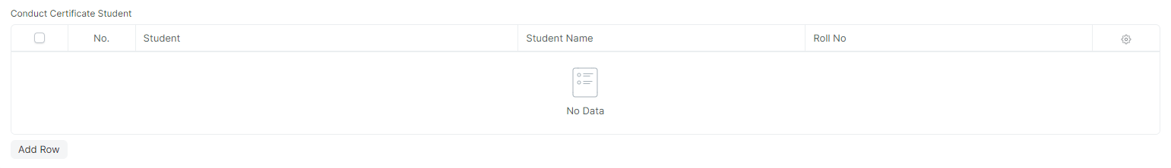

#### **Description of Changes:**

* Label Renaming is required for Program to Course.

## **Transcripts**

### **Leaving Certificate**

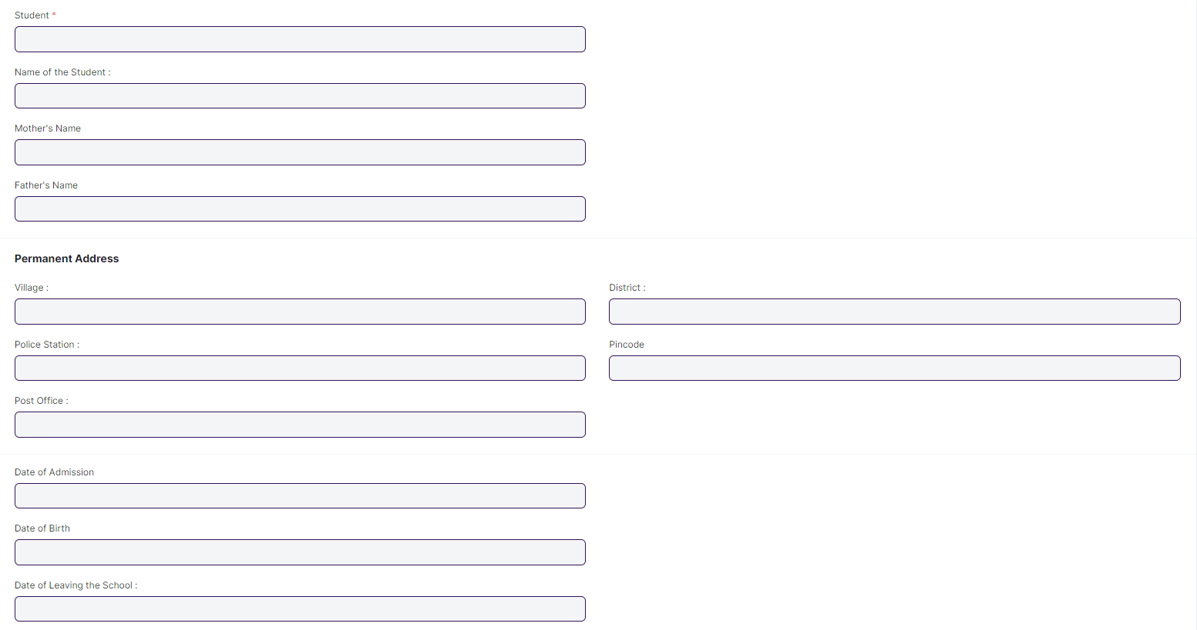

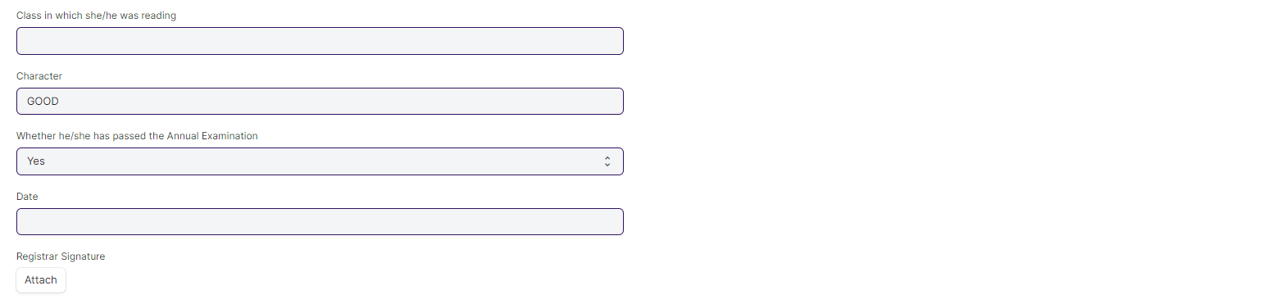

#### **Description of Changes:**

* Label Renaming is required for Program to Course.

### **Provisional Certificate**

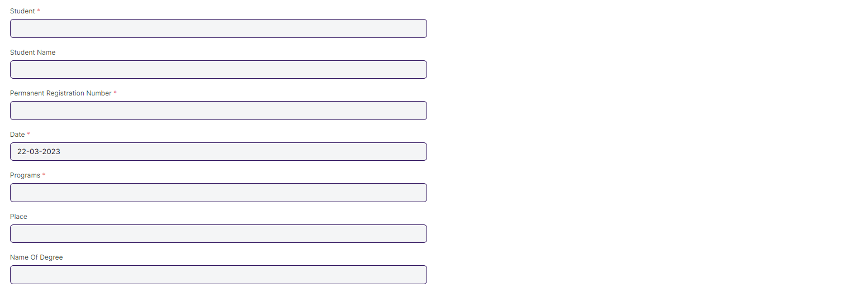

#### **Description of Changes:**

* Label Renaming is required for Program to Course.

### **Conduct Certificate**

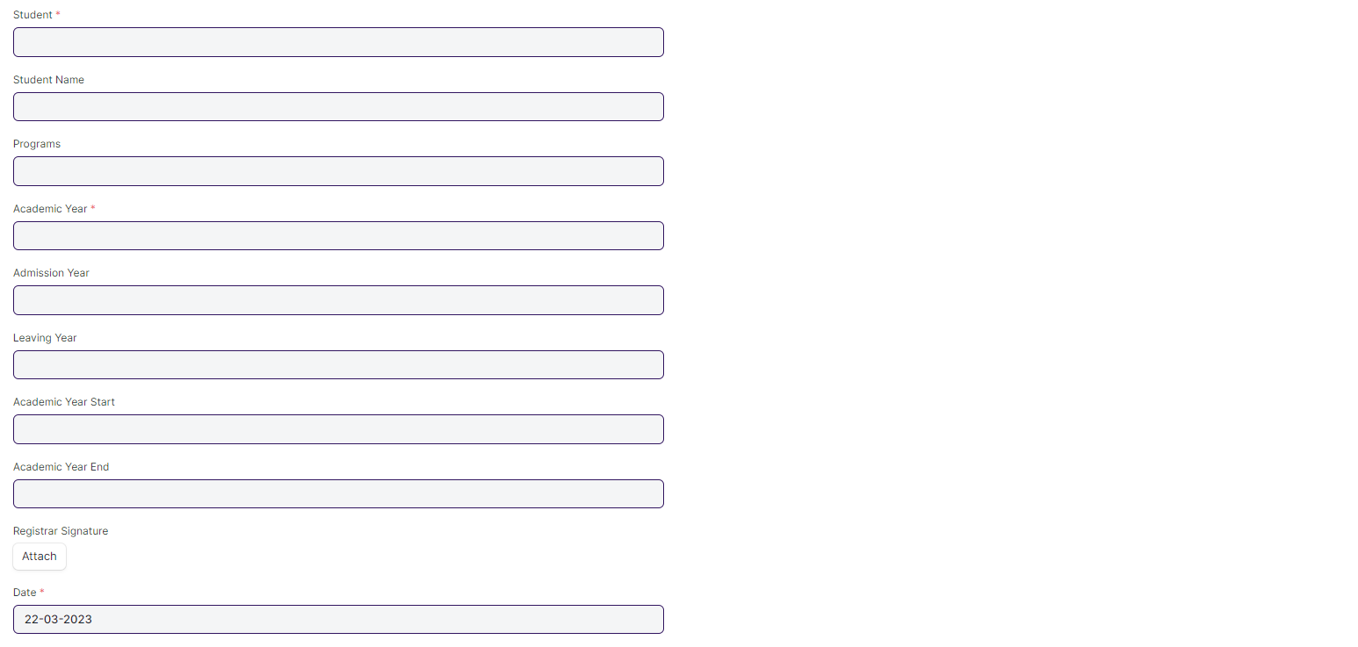

#### **Description of Changes:**

* Label Renaming is required for Program to Course.

### **Cumulative Marksheet**

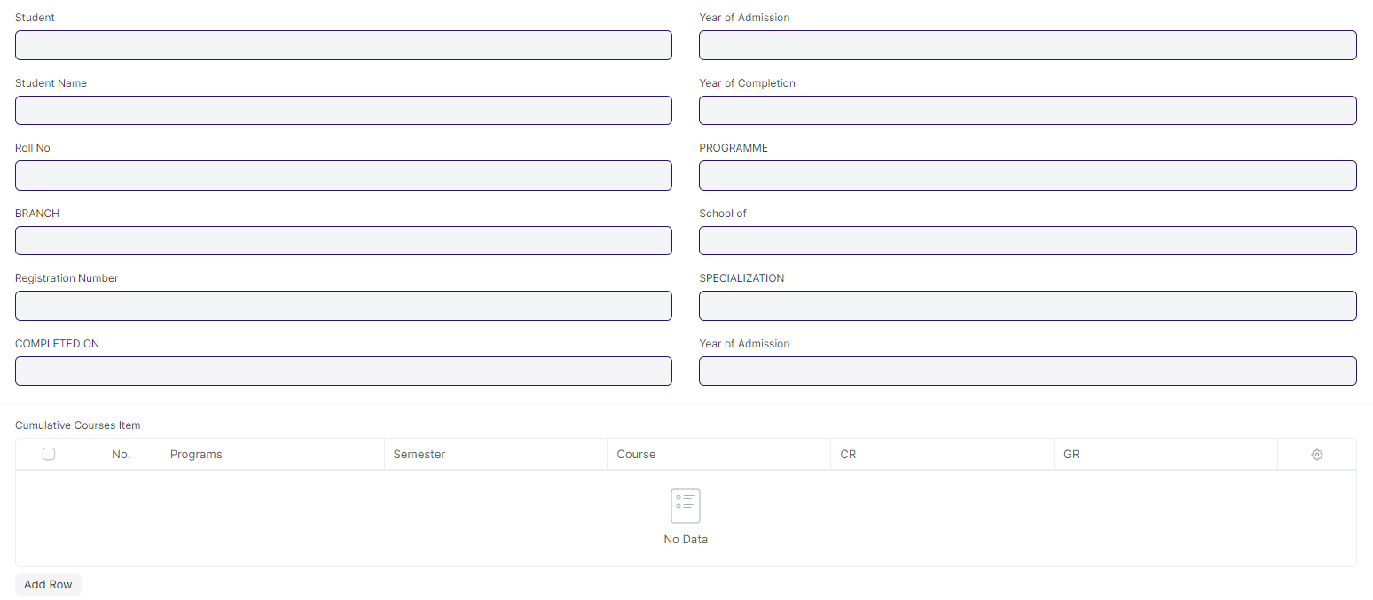

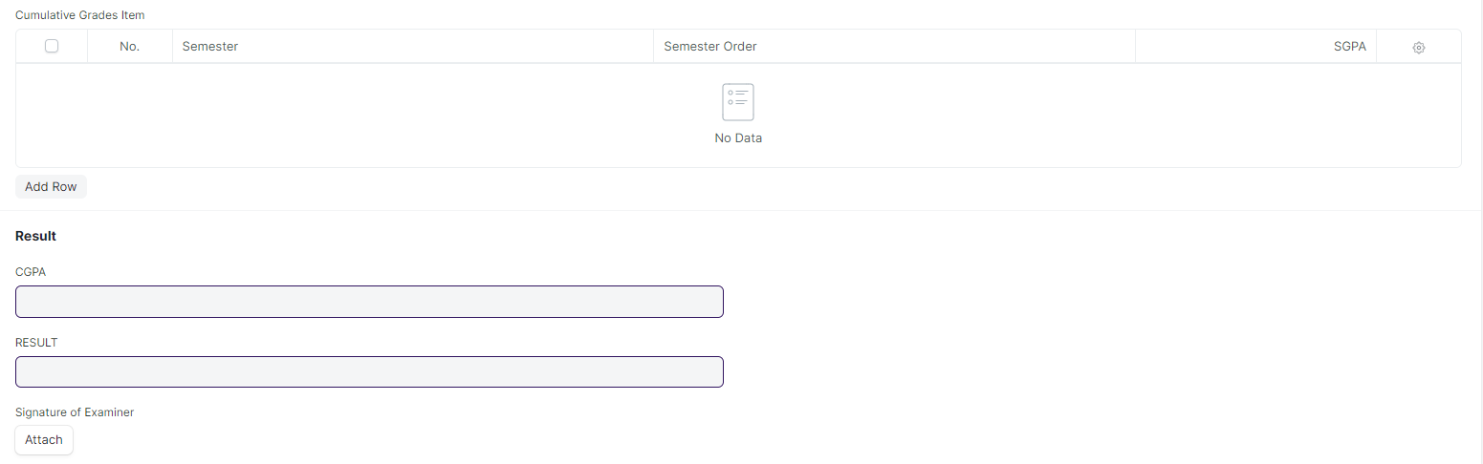

#### **Description of Changes:**

* Remove/Hide the CGPA, SGPA, and Credit features from the Cumulative Mark sheet and display the percentage and grade instead.
* Renaming of labels is required in Cumulative Courses Item child table for Course, Course Name, and Course Code to Module, Module Name, and Module Code respectively.
* Deletion of “Overall grade” Field and “Grade” Field in Cumulative Grades Item child table.